Preparation and Characterization of Activated Carbon from Agricultural Waste, Peanut Shell by Chemical Activation

1Sumitra Kamariya and 2Jilesh Pandya,

1Master of Engineering Student, 2Assistant Professor

1,2Department of Chemical Engineering, Gujrat Technological University, Ahmedabad, Gujarat, India

***Abstract:*** The activated carbon was prepared from carbonaceous agricultural waste, peanut shell by chemical activation using potassium hydroxide (KOH) and sodium carbonate (Na2CO3) at 500 °C. Peanut shells were carbonized in an inert atmosphere and then the char was mixed with a solution of chemical activating agents and H2O and Impregnation ratio was 1:1. The mixture was then activated thermally in a nitrogen atmosphere at 300°C, 400°C, 500°C, 600°C for 2 hr and finally washed and dried to obtain the activated carbon. The objectives of this work were to develop a modified method to produce activated carbon from peanut shell and to compare its physical and morphological characteristics with the activated carbon obtained at different temperature. The internal structure of the carbon was analysed with scanning electronic microscopy (SEM) and the dye adsorption capacity of each carbon was determined according to the ASTM specifications (American Society for Testing and Materials). The results of FTIR (Fourier-Transform Infrared Spectroscopy) strongly support significant chemical and spectral changes occurring with the activation of the peanut shells for potassium hydroxide and sodium carbonate treatment. According to the results proximate analysis, the highest yield of fixed carbon was obtained at 500°C for peanut shell activated carbon using sodium carbonate.High ash content was obtained at 600ºCand high ash content activated carbon sample is undesirable because it reduces the mechanical strength and adsorption capacity of activated carbon produced.High porosity with large specific surface area was achieved at 600°C according to the result of the SEM.

***Keywords:*** *Activated Carbon, Cotton Flower, Chemical Activation, Porosity.*

1. **INTRODUCTION**

Agricultural and food industries create various waste matters that need to be utilized and convert in value added product. In the present study the activated carbon was prepared from the carbonaceous agriculture waste, peanut shell by using chemical activation agent potassium hydroxide and sodium carbonate at different temperature. These waste materials generated in oil mill industries or in various villages and can be collected on community basis for reuse. Activated carbon is a well known as porous material, with large specific surface area, which is useful in various application of both gases and solutes from aqueous solution[1]. Various row materials, such as wood, peat, agricultural waste including plant materials like groundnut, cotton, wheat, sorghum, millet, maize, sesame, etc.

There are two method for the preparation of activated carbon one is physical activation and second is chemical activation. Physical activation is a two stage process, it involves carbonization of raw material followed by activation at elevated temperatures in the presence of suitable oxidizing gases such as carbon dioxide, steam, air or their mixtures.Carbonization temperature ranges between 4000C to 8000C, and activation temperature ranges between 8000C to 11000C.

Preparation of activated carbon by chemical activation is a process in which carbonization and activation is carried out simultaneously[10].Initially the precursor is mixed with chemical activating agent, which acts as dehydrating agent and oxidant.Carbonization and activation temperature ranges between 3000C to 6000C.

Activated Carbons as microporous materials are of the most important adsorbents, which have been extensively used as adsorbents, catalyst and catalyst supports in a variety of industrial and environmental applications. Activated carbon is an extremely versatile material as an effective adsorbent with its high adsorptive capacity and high surface area the activated carbon application attractive are availability, environmentally friendly material, safe and very low cost of the staring materials coupled with its high surface area.

Various materials are used to produce activated carbon and some of the most commonly used are agriculture wastes such as almond shell and walnut shell [1], palm shell [2], lapsi stone[3], palm oil shell[4], snail shell[5], cashew nut shell[6], sugarcane bagasse[7], wood[8], rice husk[9], mustard stalk, jute stalk, sesame stalk, wheat straw [10], hazelnut shell[11], bamboo[13], Sewage sludge[14],etc.

Chemical activation has been given very effective carbon with high specific surface area. The most commonly used chemical activating agents are KOH, H2SO4, ZnCl2, Na2Co3, K2CO3, NaOH, H3PO4 etc. ZnCl2 create waste disposal problem and that is environmental unfriendly[1]. This work had as a main objective to obtain activated carbon from peanut shell and to analyze their internal structure through Scanning Electronic Microscopy (SEM) and Fourier- Transform Infrared Spectroscopy (FTIR).

1. **MATERIAL AND METHOD**

Peanut shell is by-product of the peanut oil mill and peanut shell is used for the biochar production, were dried. Respective biochar were prepare in furnace at 500°C for 1 hr in absence of air, where the temperature of the reactor was controlled by means of a temperature controller and measured by a thermocouple in the bed. The process was conducted at a fixed heating rate of 10°C minute-1. Cooled down by spray of water crushed and sieved to produce samples of 100 mesh particle size called char. Char was mixed with the solution of chemical activating agent and water. Chemical activating agent use for the impregnation were KOH and Na2Co3. The presence of chemical activation agent in the interior of the precursor restricted the formation of tar and other liquids such as acetic acid and methanol during the activation.

In two stage activation, activated carbons from the respective biochar were prepared (peanut shell) in a tube furnace. KOH (Potassium hydroxide) and Na2Co3 dissolved in distilled water to prepare a saturated solution and impregnated for 6 hr, dried for 8 hr in oven at 110°C. Sample fill in to the tube of furnace and heat up to activation temperature.

The temperature was set at 300 °C, 400 °C, 500 °C and 600°C, the holding time was fixed at 2 hr in presence of 40 lit/hr nitrogen gas flow rate. The time and temperature of activation were optimized after a number of experiments. The resulting activated carbons were washed with 0.1N HCl solution to remove surface ash particles followed by hot water to remove chemical compounds until the slurry reached a pH of 6–8. The prepared carbons were then dried at 110°C for 8 hr and kept in oven.

The proximate and ultimate analysis of peanut shell activated carbon was done by standard ASTM procedures. The surface morphology of activated carbon was examined by Scanning Electronic Microscopy. The pore formation of activated carbon is mainly attributed to the addition of chemical activation agent which causes the material swell and it opens the surface structure. Details of functional group presents on the surface of peanut shell activated carbon material are obtained from FTIR studies.

1. **RESULTS AND DISCUSSION**

The proximate and ultimate analysis of the activated carbon produced by carbonization and activation of the biomass is presented in Table 1 and 2. In the tables PKAC is peanut shell activated carbon using potassium hydroxide sample and PNAC is peanut shell activated carbon using sodium carbonate sample.

As can be seen, carbon content is high in sample of peanut shell activated carbon using sodium carbonate at 500 °C. Peanut shell activated carbon using potassium hydroxide at 600 °C has the highest ash content among all the samples.

The difference found between carbon and fixed carbon content because carbon content includes all carbon present in the sample, both fixed and removed in the volatile compounds; that is why carbon content is higher than fixed carbon content. As per experiments it can be seen that peanut shell using sodium carbonate at 500°C presents a good adsorption profile.

This may be due to the development of porous of carbon during the activation process. Minimum ash content of activated carbon makes it highly favourable for commercial applications.

Table 1: Proximate analysis of peanut shell activated carbon using KOH and Na2Co3

|  |  |  |  |  |  |
| --- | --- | --- | --- | --- | --- |
| Sample code | Temperature (°C) | **% C** | **% H** | **% N** | **% S** |
| PKAC1 | 300 | 63.17 | 3.49 | 1.36 | 0.36 |
| PKAC2 | 400 | 58.06 | 3.07 | 1.36 | 0.32 |
| PKAC3 | 500 | 62.98 | 2.65 | 1.31 | 0.24 |
| PKAC4 | 600 | 61.59 | 2.37 | 1.22 | 0.21 |
| PNAC1 | 300 | 69.43 | 2.91 | 1.39 | 0.15 |
| PNAC2 | 400 | 71.37 | 2.35 | 1.14 | 0.16 |
| PNAC3 | 500 | 78.28 | 2.29 | 0.72 | 0.1 |
| PNAC4 | 600 | 75.09 | 2.9 | 0.43 | 0.08 |

Table 2: Ultimate analysis of peanut shell activated carbon using KOH and Na2Co3

|  |  |  |  |  |  |
| --- | --- | --- | --- | --- | --- |
| Sample code | Temperature (°C) | % Moisture | % Ash | % Volatile Matter | % Fixed Carbon |
| PKAC1 | 300 | 5.28 | 15.38 | 27.24 | 52.05 |
| PKAC2 | 400 | 5.74 | 18.54 | 25.1 | 50.62 |
| PKAC3 | 500 | 5.85 | 21.065 | 21.24 | 51.46 |
| PKAC4 | 600 | 7.95 | 21.52 | 20.02 | 50.51 |
| PNAC1 | 300 | 4.69 | 16 | 25.41 | 51.84 |
| PNAC2 | 400 | 4.49 | 20.5 | 22.31 | 52.67 |
| PNAC3 | 500 | 4.6 | 20.68 | 21.68 | 53.83 |
| PNAC3 | 600 | 5.72 | 20.87 | 21.25 | 52.16 |

High ash content is undesirable because it reduces the mechanical strength and adsorption capacity of produced activated carbon.

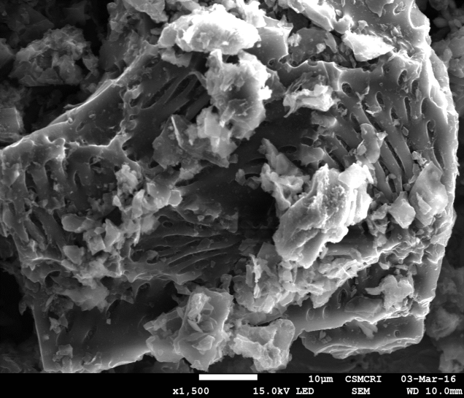

(a)

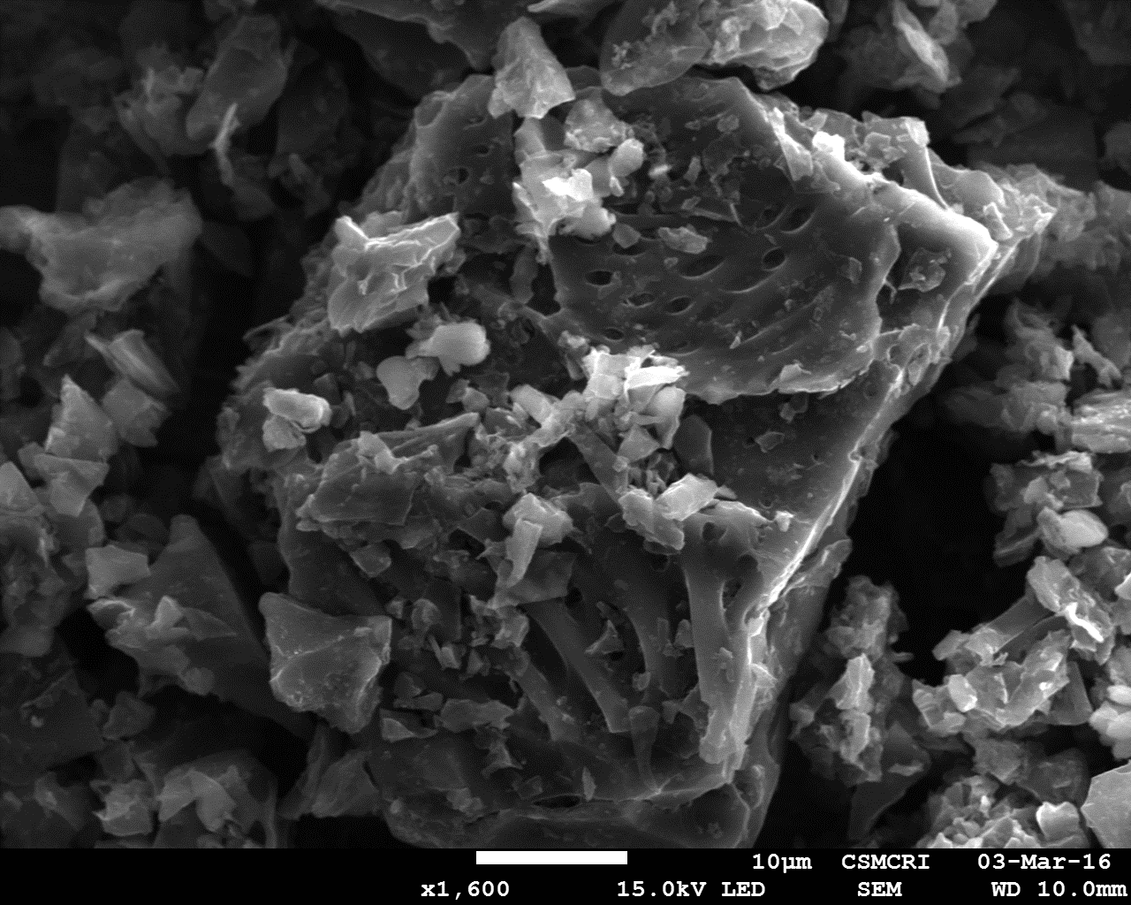

(b)

Figure 1: (a) SEM result of peanut shell activated carbon using potassium hydroxide at 500 °C & (b) SEM result of peanut shell activated carbon using sodium hydroxide at 500 °C.

The mechanism of formation of pores or the process of chemical activation by potassium hydroxide and sodium carbonate. In a peanut shell, activating agent at high concentrations gives acidity to the solution, separates the cellulose, and produces a partial depolymerization of hemicellulose and lignin, the main components of the matrix, thus leading to a decrease in mechanical resistance and swelling of the particle.



(a)



(b)

Figure 2: (a) FTIR result of peanut shell activated carbon using potassium hydroxide & (b) FTIR result of peanut shell activated carbon using sodium carbonate.

At high concentrations of activation agent, the original cellular morphology of the precursor is lost because a large part of the cellulosic structure is degraded and extracted from the interior to the exterior of the particle. The activating agent molecules in the interior of the particles produce a dehydrating effect on the already transformed components (cellulose, hemicellulose, lignin) during the heat treatment. It is very possible that cross-linking reactions are predominant at higher temperatures and impregnation ratios, with subsequent reduction in the exit of volatile matter and tars [10].

Figures 2(a)–(b) show the clear development of pores by activation of peanut shell activated carbon using potassium hydroxide andsodium carbonate at 500 °C and given batter adsorption compare to other samples.

Details of functional group presents on the surface of peanut shell activated carbon material can be understood from the FT-IR spectrum (Figure 2). For both activated carbon sample, in the range of 3650–3200 cm-1 a broad O-H stretching was observed. Between 2, 850 and 2, 950 cm-1, C-H stretching vibration can be observed for aliphatic methyl and methylene groups. The band at 1060 cm-1 for the activated carbon can be attributed to carboxylic acid, which is possibly formed due to extraction of H element and OH groups from the aromatic rings during impregnation and heat-treatment stages as a result of the dehydration effect of activating agents. The presence of OH groups in plane C-H vibrations in C=C-H structure is evident from the peaks in the range of 1300–1450 cm-1. Olefinic vibrations take place between 650 and 750 cm-1, which is evident in both the samples.

**CONCLUSION**

Agricultural wastes such as peanut shell considered as suitable raw materials for preparation if activated carbon by using different chemical activating agents.

The physical and chemical properties of activated carbon vary with the temperature of activation also it was depends on the carbonious row material and contact time during the impregnation and activation. Influence of activation temperature, time and impregnation ratio on development of porosity of activated carbon. The activation was performed using potassium hydroxide and sodium carbonate under different operating conditions of temperature.

According to the results proximate analysis, the highest yield of fixed carbon was in peanut shell activated carbon using sodium carbonate at 500˚C. Peanut shell activated carbon using potassium hydroxide at 600 °C has the highest ash content among all the samples. High porosity with large specific surface area achieved according to the result of the SEM in both sample at 500˚C.

***Acknowledgements***

The authors are thankful to CSMCRI for constant encouragement and providing facilities to carry out this research work with permission.

***References***

1. P. Pragya, S. Sripal, Y. Maheshkumar, “Preparation and Study of Properties of Activated Carbon Produced from Agricultural and Industrial Waste Shells” Journal of Research Journal of Chemical Sciences Vol. 3(12), 12-15, December 2013.
2. D. Adinata, W. Daud, M. Aroua, “Preparation and characterization of activated carbon from palm shell by chemical activation with K2CO3” Journal of Bioresource Technology 98, 145–149, 2007.
3. J. Sahira, A. Mandira, B. Bhadra, P. Raja ram, ” Effects of activating agents on the activated carbons prepared from lapsi seed stone” journal of research journal of chemical sciences, vol. 3(5), 19-24, may, 2013.
4. K. Hussaro, “Preparation of activated carbon from palm oil shell by chemical. activation with Na2CO3 and ZnCl2 as imprenated agents for H2S adsorption” journal of american journal of environmental sciences 10 (4): 336-346, 2014.
5. R. Gumus, I. Okpeku, “Production of activated carbon and characterization from snail shell waste (helix pomatia)” journal of advances in chemical engineering and science, 5, 51-61, 2015.
6. R. Subramaniam, s. Ponnusamy, “Novel adsorbent from agricultural waste (cashew nut shell) for methylene blue dye removal: optimization by response surface methodology “ journal of water resources and industry11, 64–70, 2015.
7. H. Karunarathne, B. Amarasinghe, “Fixed bed adsorption column studies for the removal of aqueous phenol from activated carbon prepared from sugarcane bagasse” journal of energy procedia 34, 83 – 90, 2013.
8. J. Baseri, P. Palanisamy, P. Sivakumar, “Preparation and characterization of activated carbon from thevetia peruvianafor the removal of dyes from textile waste water” journal of advances in applied science research, 3 (1):377-383, 2012.
9. N. Yahayaa, I. Abustana, M. Mohamed latiffa, O. Bellob, M. Ahmadb, “Fixed-bed column study for cu (II) removal from aqueous solutions using rice husk based activated carbon” journal of international journal of engineering & technology, vol: 11 no: 186-190, 2011.
10. S. Maiti, S. Purakayastha, B. Ghosh, “Production of low-cost carbon adsorbents from agricultural wastes and their impact on dye adsorption” Journal of Chem. Eng. Comm., 195:386–403, 2008.
11. M. Soleimani, T. Kaghazchi, “agricultural waste conversion to activated carbon by chemical activation with phosphoric acid”Journal of Chem. Eng. Technol., 30, No. 5, 649–654, 2007.
12. M. Yeganeh, T. Kaghazchi, M. Soleimani, “Effect of raw materials on properties of activated carbons” Journal of Chem. Eng. Technol. 29, No. 10, 1247–1251, 2006.
13. B. Hameed, A. Din, A. Ahmad, “Adsorption of methylene blue onto bamboo-based activated carbon: Kinetics and equilibrium studies”, Journal of Hazardous Materials 141, 819–825, 2007.
14. F. Rozada, L. Calvo, A. Garcıa, J. Martın-Villacorta, M. Otero, “Dye adsorption by sewage sludge-based activated carbons in batch and fixed-bed systems” Journal of Bioresource Technology 87, 221–230, 2003.